**PROJECT SYNOPSIS**

**Project Name**

*Submitted towards the partial fulfillment of the criteria for award of Genpact Data Science Prodegree by Imarticus*

*Submitted By:*

*Neeharika Ithapu*

*Leroy Dsa*

*Course and Batch: DSP 14/15 2020*



# Abstract

We study machine learning to be able to predict and validate the important key features in our data that are necessary to help us structure a meaningful conclusion to our task.

In this project we are tasked with analyzing the key features such as default indicator, payment information, credit history, etc. in order to formulate the possibility of loan applicants defaulting. Over the past years, loan defaulters have been increasing in number, thus resulting in higher risk to the investor. By classifying the applicant into defaulter or not, we aim to curb losses and thus increase profitability.

**Keywords**

*Disclaimer: *Data shared by the customer is confidential and sensitive, it should not be used for any purposes apart from capstone project submission for PGA. The Name and demographic details of the enterprise is kept confidential as per their owners’ request and binding.*

# Acknowledgements

We are using this opportunity to express my gratitude to everyone who supported us throughout the course of this group project. We are thankful for their aspiring guidance, invaluably constructive criticism and friendly advice during the project work. I am sincerely grateful to them for sharing their truthful and illuminating views on a number of issues related to the project.

Further, we were fortunate to have great teachers who have readily shared their immense knowledge in data analytics and guide us in a manner that the outcome resulted in enhancing our data skills.

We wish to thank, all the faculties, as this project utilized knowledge gained from every course that formed the DSP program.

We certify that the work done by us for conceptualizing and completing this project is original and authentic.

Date: March 13th, 2021 Member 1: Neeharika Ithapu

Place: Thane Member 2: Leroy Dsa

# Certificate of Completion

I hereby certify that the project titled “**Loan Prediction Default using Machine Learning Techniques**” was undertaken and completed under my supervision by **Neeharika Ithapu** and **Leroy Dsa** from the batch of DSP 14 & 15 (March 2021)

Mentor: Prachi Samant

Date: March 13th, 2021

Place – Thane

Table of Contents

Abstract 2

Acknowledgements 2

Certificate of Completion 4

1. Introduction 6

1.1. Objective: 6

1.2. Purpose of Study: 6

1.3. Company Study 6

1.4. Data Source 6

1.5. Tools and Techniques 6

2. Treating Data 7

2.1. Analysis of missing values 7

2.2. Imputation of missing values 7

2.3. Feature Selection / dropping irrelevant columns 7

3. Exploratory Data Analysis 8

3.1. Feature Analysis 8

a. Default Indicator: 8

b. Loan Amount: 9

c. Interest Rate : 9

d. Installment : 10

e. Home Ownership : 10

f. Loan Term : 11

g. Company assigned loan grade : 11

h. Purpose of loan : 12

i. Loan Amount Vs Term 12

j. Loan Amount vs Verification Status 13

k. Default Indicator over time 13

3.2. Label Encoding 13

3.3. Spitting data into test and train 14

3. Model Building 15

4.1. Logistic Regression 15

4.1.1. Tuning Techniques for LR 15

4.2. Tree Based Models 18

4.2.1. Decision Tree Classifier 18

4.2.2. Tuning DT 19

4. Key Highlights 24

5. Inferences 24

# Introduction

## **Objective**:

Data provided by - ‘XYZ Corporation Lending Data Project’.

First Analysis – Txt file containing the loans issued by XYZ Corp through 2007-2015.

Objective – Our primary objective of this project is to predict the probability of the customer defaulting by using the past data.

Prediction – As part of this exercise, in the given set of new predictor variables, we will offer the prediction 1 -> Defaulter or 0 -> Non-Defaulter.

## Purpose of Study:

Our main purpose is to predict if a borrower will default or not. By doing so, our employer can flag such borrowers and avoid taking a risk. This, however, does not necessarily lead to highest return on investment (ROI) because by completely avoiding potential defaults, one may also be avoiding riskier loans that may lead to higher ROI with possibility of default at some point in the future. In order to maximize ROI, one needs to optimize ROI instead. In our project, we work on the simpler problem that is to predict loan defaults.

* 1. Company Study:

XYZ Corp has provided a txt file containing the complete loan data through the years 2007-2015. The data contains the indicator of default, payment information, credit history, etc.

* 1. Data Source:

File Name: XYZCorp_LendingData.txt

* Data Set contains complete loan data for all loans issued by XYZ Corp. through 2007-2015.
* Data contains categorical and numerical observations
* Observations – 855969
* Columns – 73
* Column ‘default_ind’ – dependent variable and contains 0 -> non-defaulters and 1 -> defaulters
  1. Tools and Techniques:

Tools: Juypter Notebook

Techniques: Logistic Regression, Decision Tree

# Treating Data

## Analysis of missing values

To correctly ascertain the usefulness of the data, we need to analyze the quantity of missing data from our data source. Setting a reasonable threshold of 50%, we can proceed to drop all features which contain missing values above this threshold.

We observed, 21 columns which contain above 50% missing values. We are left with 52 columns attached to the dataset.

## Imputation of missing values

Features which contain missing values can be treated in the 2 ways –

1. Data Type – ‘Object’ –  
   For instances when the data type is an object, we resort to replacing all missing values with the mode or highest frequency representative.
2. Data Type – ‘Int64’ or ‘’float64’ -  
   These instances being numerical in nature, we replaced with the mean of feature set for best results.

## Feature Selection / dropping irrelevant columns

Checking for uniqueness of variables

1. loan_amnt Vs funded_amnt  
   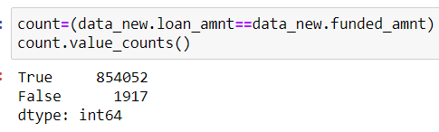
2. loan_amnt Vs funded_amnt_inv

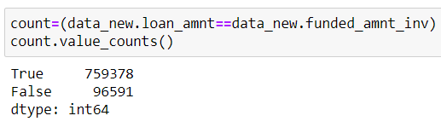  
  
We can see that loan_amnt,funded_amnt,funded_amnt_inv are highly correlated, hence out of 3 we retain one column. We have decided to retain the ‘loan_amnt’

1. After careful consideration, we have dropped the following features as irrelevant -  
   id, member_id, sub_grade, title, zip_code (last digits are masked XX), emp_title

# Exploratory Data Analysis

# **Feature Analysis**

We are considering 44 feature columns in our exploratory data analysis.

### Default Indicator:

Analyzing the dependent variable shows us that from past data, vast majority of customers have not defaulted and is a good sign. Of the total number of observations, 5.43% are defaulters. This is comparatively very low, however is not an indication of anything.

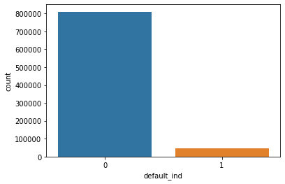

Inference: From the above chart, we see that 809502 observations show non-defaulters vs 46467 who are defaulters. It’s clear that we have been given an unbalanced dataset.

1. Loan Amount:  
   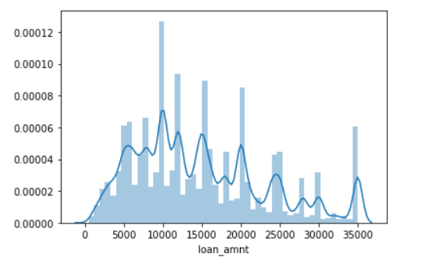  
   Inference: The loan amount looks to be distributed between 5000 and 35000
2. Interest Rate :   
   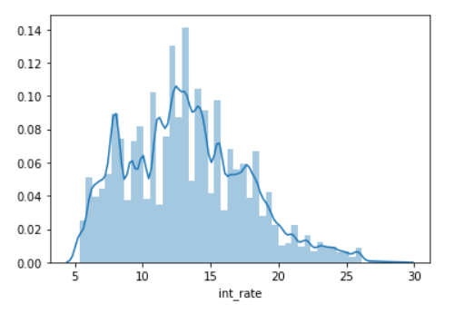  
   The interest rate forms a bell and seems to be distributed mainly between 5.5 to 25 %
3. Installment :   
   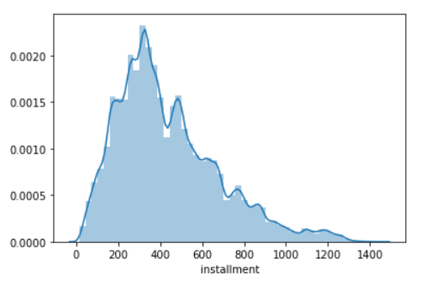  
   Like the above, the Installments seem to be distributed between 100 and 800
4. Home Ownership :  
   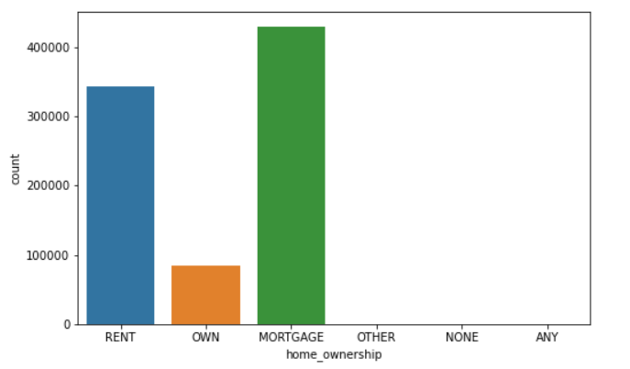  
   Nearly 50% of home owners have mortgaged their homes in order to afford the loan, while approx. 40% stay on rent.
5. Loan Term :  
   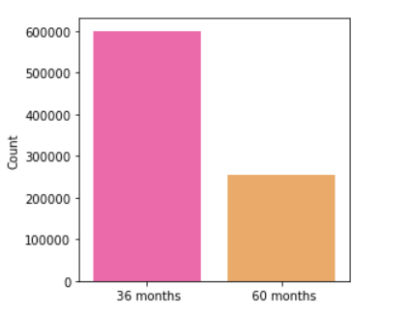  
   Nearly 60% applicants have taken a shorter term while 40% have applied for a longer term.
6. Company assigned loan grade :  
   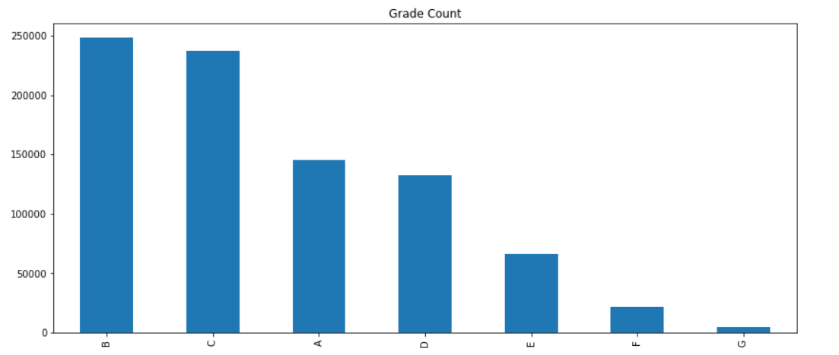  
     
   B Grade loans were the highest sold, followed by C Grade and then A Grade. Marginal difference between the volumes of loans provided between B and C Grade loans.
7. Purpose of loan :  
   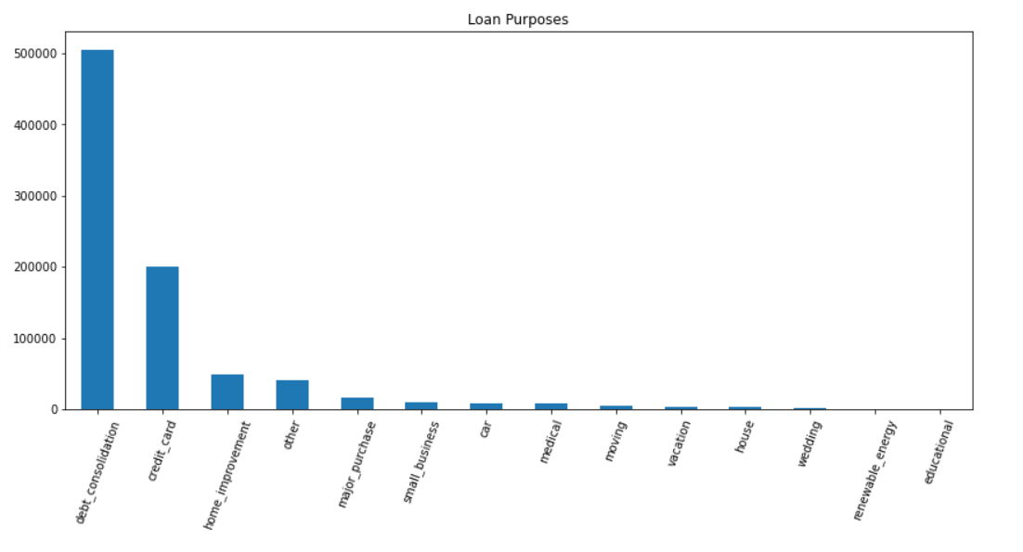  
   As you may notice, majority loan applications have taken loans for debt consolidation, which is strikingly higher as compared to any other purpose. This sums up to nearly 58% of the applicants, followed by credit card at 23%.
8. Loan Amount Vs Term  
   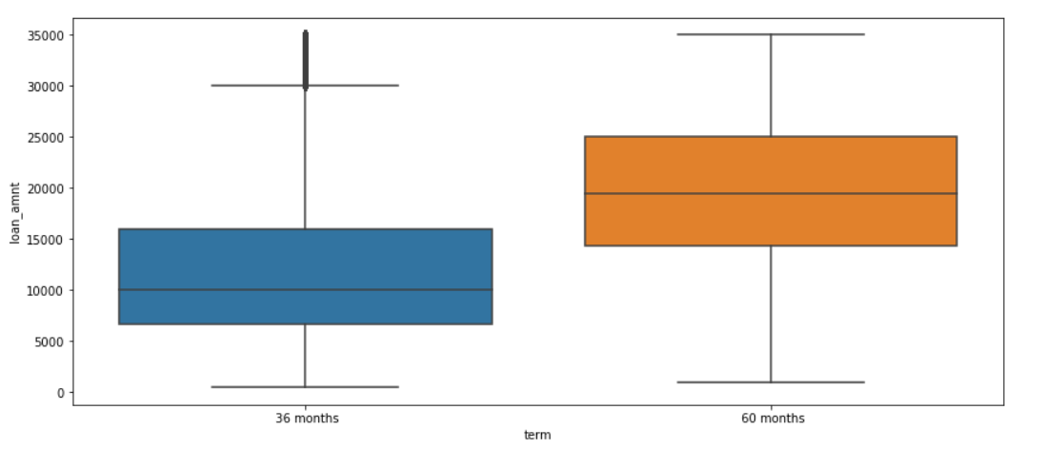  
   This helps us understand that the higher the loan amount, the greater tenure of the loan. Loan amounts greater than 15000 were pushed to 60 months.
9. Loan Amount vs Verification Status  
   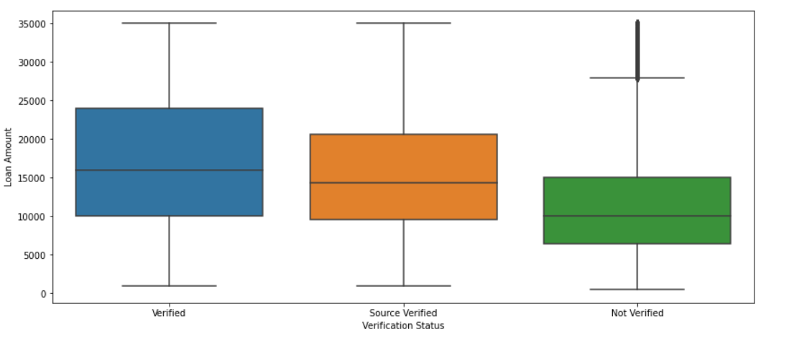  
   In most cases where the loan amount was higher than 100k, the income source was verified. Lower amounts may have gone unverified.
10. Default Indicator over time  
    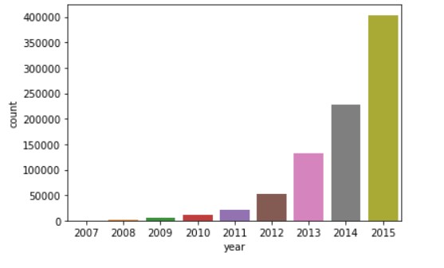  
    As the years move forward, the need for default indicator grows more important in data analysis. Data collected before 2013 can be considered negligible as it accounts for only 6% of the data.  
    1. Label EncodingA brief of what we are trying to achieve - Sklearn provides a very efficient tool for encoding the levels of categorical features into numeric values. LabelEncoder encode labels with a value between 0 and n_classes-1 where n is the number of distinct labels. If a label repeats it assigns the same value to as assigned earlier.

We apply this technique to all observations where the data type is ‘Object’.

* First we collate all columns with the type ‘Object’ as a list.
* Then we proceed to apply the technique by sklearn to encode the observations which are ‘Object’ to numerical.  
    
  Now, all data is numerical and ready for splitting into train and test.

## Spitting data into test and train

The data is divided based on the ‘issue_d’ variable from which the records between June-2007 to May-2015 will go into Training data sample while the records from June-2015 to Dec-2015 will fall in the Testing data sample.

1. Train and Test split
2. Post split, the column ‘issue_d’ is dropped, as it has no purpose beyond this.
3. Now splitting into ‘x_train’, ‘x_test’, ‘y_train’, ‘y_test ‘  
     
   1. **Standardization by scaling**

Standardization of datasets is a common requirement for many machine learning estimators implemented; they might behave badly if the individual features do not more or less look like standard normally distributed data: Gaussian with zero mean and unit variance.

In practice we often ignore the shape of the distribution and just transform the data to center it by removing the mean value of each feature, then scale it by dividing non-constant features by their standard deviation.

Since the data distribution of the dependent variable leans more towards non-defaulters, there is a high probability of over fitting in case standardization of data is not achieved.

# Model Building

## 4.1. Logistic Regression

**Logistic regression** analysis is used to examine the association of (categorical or continuous) independent variable(s) with one dichotomous dependent variable.

LR belongs to supervised category, used for classification only. Logistic range is 0-1 (specifically either 0 or 1), hence suitable for binary classification. LR uses sigmoid function. This can convert any real valued data (-infinity to +infinity) to 0-1. LR follows MLE method (Maximum Likelihood Estimate). Intention is to get best value for Beta parameters such that predicted value is accurate. LR develops a probability matrix for each observation of data. As the range is 0-1, default threshold is 0.5, whichever class of the obs has more value it predicts that obs belongs to that class.

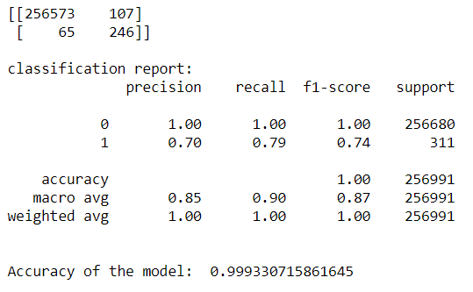

The confusion matrix, accuracy score, classification report is presented above.

Referring to the above confusion matrix, we can clearly see that the Type I error is 107 while the Type II error is 65.

Since the data is unbalanced, we would not focus on the accuracy of the model but instead tune the model for less Type I and Type II errors.

### 4.1.1. Tuning Techniques for LR

Adjusting Threshold:  
Adjusted the threshold b/w 0.4 to 0.7 to predict for class of interest and total error  
Considering an ideal value of 0.6 where type1 and total error is less.  
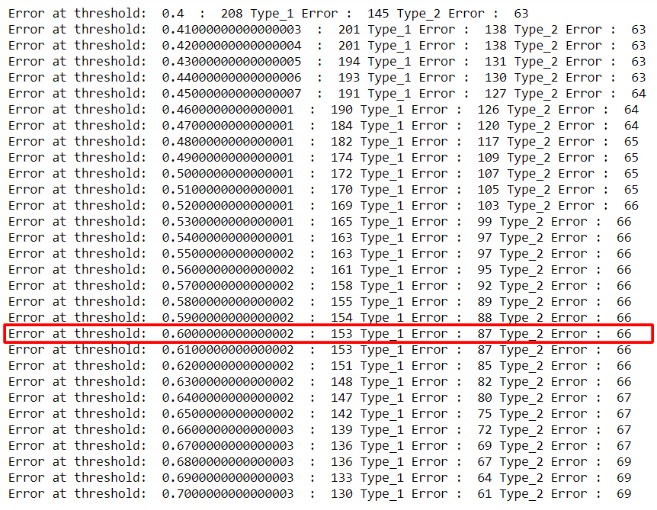  
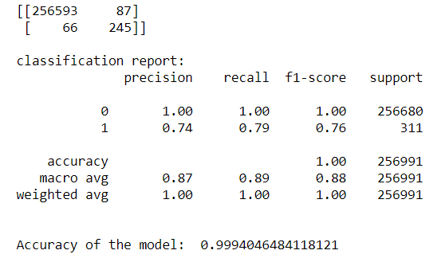  
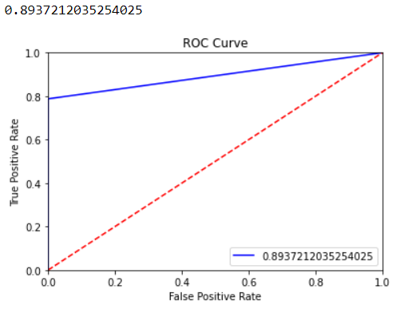

1. SGD Classifier
   1. Stochastic gradient descent (SGD) computes the gradient using a single sample. In this case, the noisier gradient calculated using the reduced number of samples tends SGD to perform frequent updates with a high variance.
   2. Reinforcing model which takes 1 observation at a time for step wise learning thus optimising the error value in each step.
   3. This is an optimising technique which ends up at best beta parameters by taking one observation at a time and on the error got it will learn and update beta parameters before proceeding to next iteration. Once updated, these values are considered and again error is generated and goes on.
   4. Model will stop when max iterations mentioned are reached or when it meets zero convergence rate (where for certain no of iterations model will get same error). In our case we have set early_stopping=True so that it wont unnecessarily go till max iterations and will stop at zero convergence once it gets 5 times same error o/p as we have mentioned n_iter_no_change=5.

Shuffle=True, in order to shuffle the order of data in every epoch

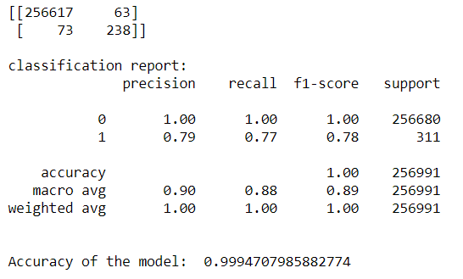

We fixed on the alpha(learning rate) value as 0.0001 after considering the below values:  
  
#alpha= 0.01 >> acc= 99.93 type2=160 type1=4

#alpha= 0.001 >> acc= 99.94 type2= 93 type1= 54

#alpha= 0.0001 >> acc= 99.94 type2=73 type1=63

#alpha= 0.00001 >> acc= 99.86 type2=65 type1=285

1. Cross Validation with Logistic Regression
   1. Cross-validation is a resampling procedure used to evaluate machine learning models on a limited data sample. The procedure has a single parameter called k that refers to the number of groups that a given data sample is to be split into.
   2. This is the technique where validation is done multiple times on the data by splitting into groups for cross validation.
   3. This allows to divide data into k no. of folds where k can be decided by us. Ideally we go as below: if total no of obs < 1 lakh - k=10 and > 1 lakh - k=5.
   4. k-1 folds are taken for train data and remaining fold for validation testing. Any of the folds can be taken randomly as testing and training.
   5. We give n_splits=5 so that 5 folds are created where in 4 are training and 1 is validation testing.
   6. 5 models are created with respective accuracies and mean accuracy is generated. This mean value is the overall accuracy of the process

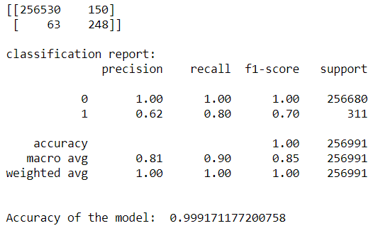

## 4.2. Tree Based Models

### 4.2.1. Decision Tree Classifier

* Decision tree is a type of supervised learning algorithm that is mostly used in classification problems. It works for both categorical and continuous input and output variables.
* In this technique, we split the data into two or more homogeneous sets based on most significant splitter / differentiator in input variables.
* Advantages include easy, useful in data exploration, less data cleaning required, data type is not constraint, non-parametric method.
* Decision tree splits the nodes on all available variables and then selects the split which results in most homogeneous sub-nodes.
* criterion=gini is the default for decision tree classifier. It performs only Binary splits. Higher the value of Gini higher the homogeneity. CART (Classification and Regression Tree) uses Gini method to create binary splits.
* Let’s assume there are 2 vars which have same gini index, it selects randomly when we run multiple times the script later, in order to select the same variable every time random_state is passed.  
  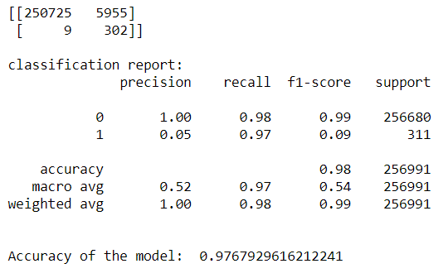

### 4.2.2. Tuning DT

#### 1. Tree Pruning

Overfitting is one of the key challenges faced while using tree based algorithms. If there is no limit set of a decision tree, it will give 100% accuracy on training set because in the worse case it will end up making 1 leaf for each observation. In order to avoid this we set some hyper parameters to prune tree so that we can put constraints on tree size.

Minimum samples for a terminal node (leaf): Generally lower values (here 5 ) should be chosen for imbalanced class problems like above because the regions in which the minority class will be in majority will be very small.

* Maximum depth of tree (vertical depth): Used to control over-fitting as higher depth will allow model to learn relations very specific to a particular sample. Here 10.
* Maximum number of terminal nodes: Since binary trees are created, a depth of ‘n’ would produce a maximum of 2^n leaves by default which causes over fitting. Hence consider accordingly (in this case 200).

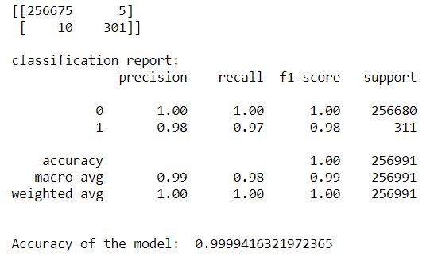

#### Bagging Techniques:

* It is weak learner as it suffers from over fitting. In most cases single decision tree is not sufficient to do predictions on data.
* We built and combine multiple DT and decide on the predictions based on avg.
* Parallel Algorithm where trees are built in parallel fashion into the memory.
* Bags of samples are created depending on n_estimators parameter passed by user.
* Samples are selected from training data randomly in bags with replacement.
* Now multiple DT’s are created parallelly and then testing data is passed to each DT and each tree will do predictions.
* Depending on mode value as this is classification data final prediction is done.

#### **Extra trees Classifier:**

Above is the process followed in this technique and default no of trees are 10. We can change this and validate. Accordingly, we tried from 10 to 100  
  
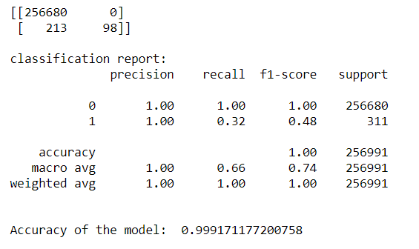

#for 10 type2 err: 141 type1:1481 acc:99.36

#for 50 type2 err: 207 type1 :0 acc:99.91

#for 100 type2 err: 199 type1 :1 acc:99.92

#for 500 type2 err: 213 type1:0 acc:99.91

Type2 error remains high for different n_estimators, hence not considering this model.

#### **Random Forest:**

* Process in similar but we can build more trees.
* Sampling of obs is randomly done apart from this here variables are also sub-setted randomly

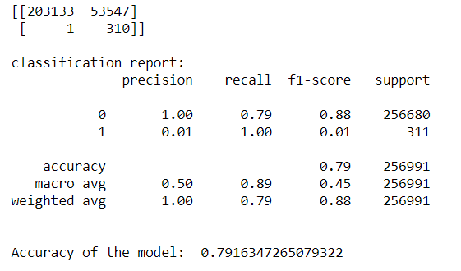

#for 50 estimtors type1 err: 51569, type2 err:2 acc: 79.93

#for 100 estimators type1 err: 53547, type2 err:1 acc:79.16

#Accuracy is dropping and type1 error is high, hence we go for better model

#### **Boosting Techniques:**

* This is sequential process where at a time one bag of sample is created in one iteration. Samples are selected from around 60 % training data randomly in bags with replacement.Once bag is created train data is passed and DT is created.
* Test data is not introduced to model till we reach final model according to n_estimators passed. Instead once DT is created in one iteration, remaining training data is passed and then predictions are done and highlights data points which were missclassfied.
* In the next iteration this data points are taken into next bag and then learns and predicts going forward in order to reduce errors. This process continues till n_estimators value is reached or zero convergence is achieved and model is taking as final one. Once final model is built testing data is passed to predict.

**3.1. Gradient Boosting Classifier:**

Restricted to decision Tree tuning.

In case of highlighting misclassifications, this method adds additional weights to these data points so that probability of selecting these in the next batch increases.

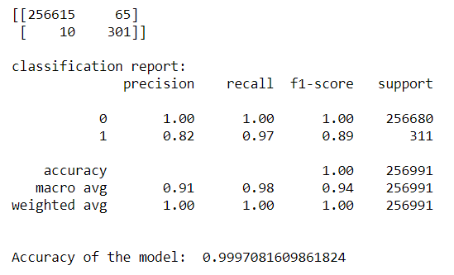

#for 50 estimators type1: 74 type2:11 acc:99.96 precision value for 1 is 0.80

#for 100 estimators type1: 63 type2:10 acc:99.71 precision value for 1 is 0.83

#for 130 estimators type1: 65 type2:10 acc:99.97 precision value for 1 is 0.82

#for 150 estimators type1: 1586 type2:10 acc:99.38 precision value for 1 is 0.16

# Key Highlights

We choose pruned Decision Tree model as our final model as we notice minimum errors and best accuracy results from this as compared to others.

# Inferences

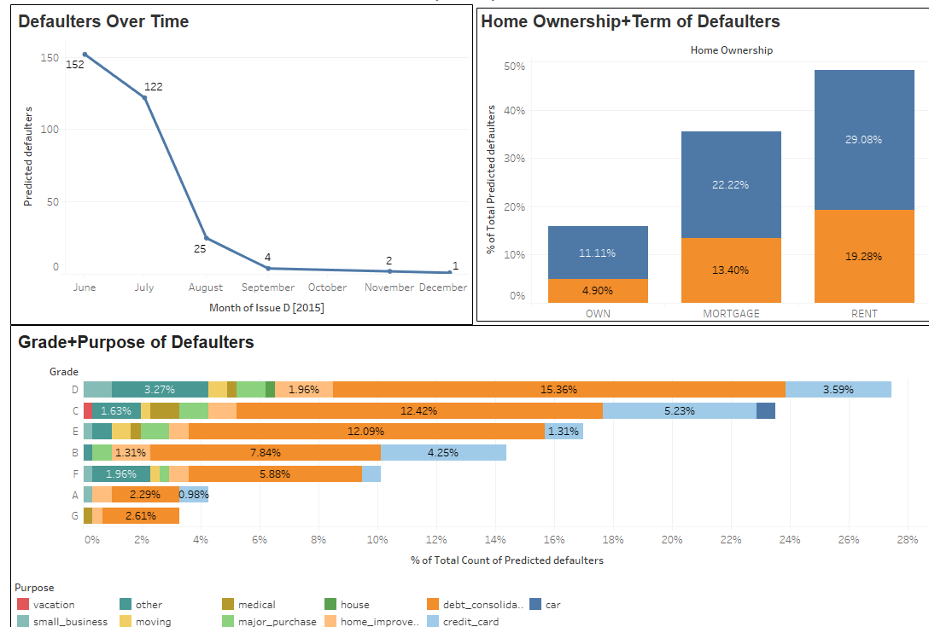

By analysing further, we can make the following conclusions:

Our test data shows us that there are 99.88% non-defaulters while 0.12% are defaulters. This 0.12% sums up to a total of (USD) 4,485,100 which is at risk.

As observed from the graphs collecting data as part of ‘**Grade**’ and ‘**Purpose**’ play a vital role in validating an accurate prediction.

Highest number of defaulters are predicted for Grades **C** (23%) and **D** (27%) seen primarily under credit card and debt consolidation. 58% -> Debt consolidation while 16%-> Credit card amongst defaulters. These are the high-risk factors and must be assessed carefully before processing the loan.

**Positive key notes:**

As shown in the graph, the defaulters over time appear to be reducing. This could be a result of machine learning implementation to curb defaulters which is benefitting the investor.

We also notice that all applicants applying with the purpose – ‘renewal_energy' and 'wedding' loans look to be the safest category as we find no defaulters.